Leslie Richards, (Mrs. J. B. Richards II)
National Chairman, Junior Membership Committee
P O Box 6695, Chesterfield, MO 63006-6695
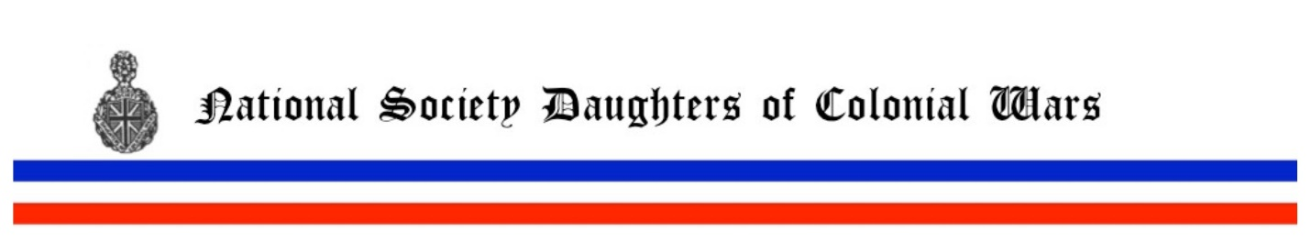
leslie@jbrichards.net 636 220 2442
Ladies,
In this society Junior Members are women who join from age 18 through 39. They may remain Juniors until age 49. We are going to try to increase our activity for and with Juniors and encourage our members to recruit more Junior members. You'll be hearing more on that subject as time goes on. In order to be effective, we'd like to be better able to identify our current Junior members. To that end, please begin making a list of your juniors, perhaps marking them in your local yearbooks. I will be contacting each chapter requesting a list of your junior members, so if you get that ready, you could send to me any time.
There has been some interest in a Junior Member pin. I'd like to hear from our chapters to know if you like that idea. A pin one could wear even if she is not a current Junior but joined as a junior? OR only those who join and are still juniors? Send me your input please! I personally love working on insignia things, so I'm very interested in your feedback; from chapters, officers or members in general. We will present possible designs, costs, "rules" etc. before making a decision, but input will be appreciated! I envision a pin that can be placed on the official ribbon of course! And as an aside, I have no skin in this game, I wasn't smart enough to join when I was junior age!
Additionally, if you have ideas for activities specifically targeted for our younger members, please share them. I'm looking for good ideas! We need to work on recruiting younger members in order to guarantee our future membership health!

Leslie Richards
National Chairman, Junior Membership Committee

